|  |  |
| --- | --- |
| Health | Two wine glasses beside cutlery |
| Spaghetti noodles decorated with cooked sea shells in white plate | Fruit salad on fresh green lettuce |

|  |
| --- |
| Created by  Basani Nagasai  Basani Naga Venkat  Choudum Vinayakaraj  Anshul Tyagi |

# Medical informatics

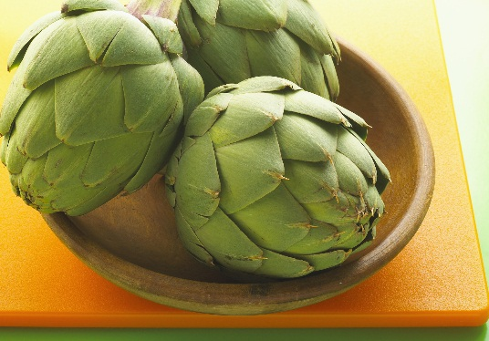

## Health – important aspect of life

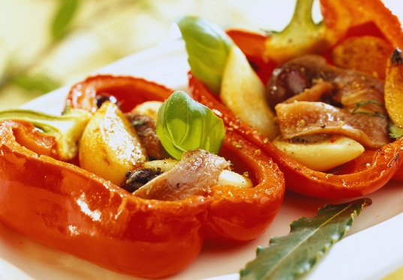

## Well being mentally and physically

